3.70: The firecracker’s falling time can be found from the usual
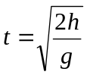
The firecracker’s horizontal position at any time t (taking the student’s position as 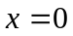) is 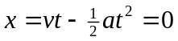 when cracker hits the ground, from which we can find that 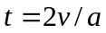. Combining this with the expression for the falling time:
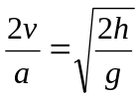
so
